Scripts for Scene: **WTInside_Cantilever1**

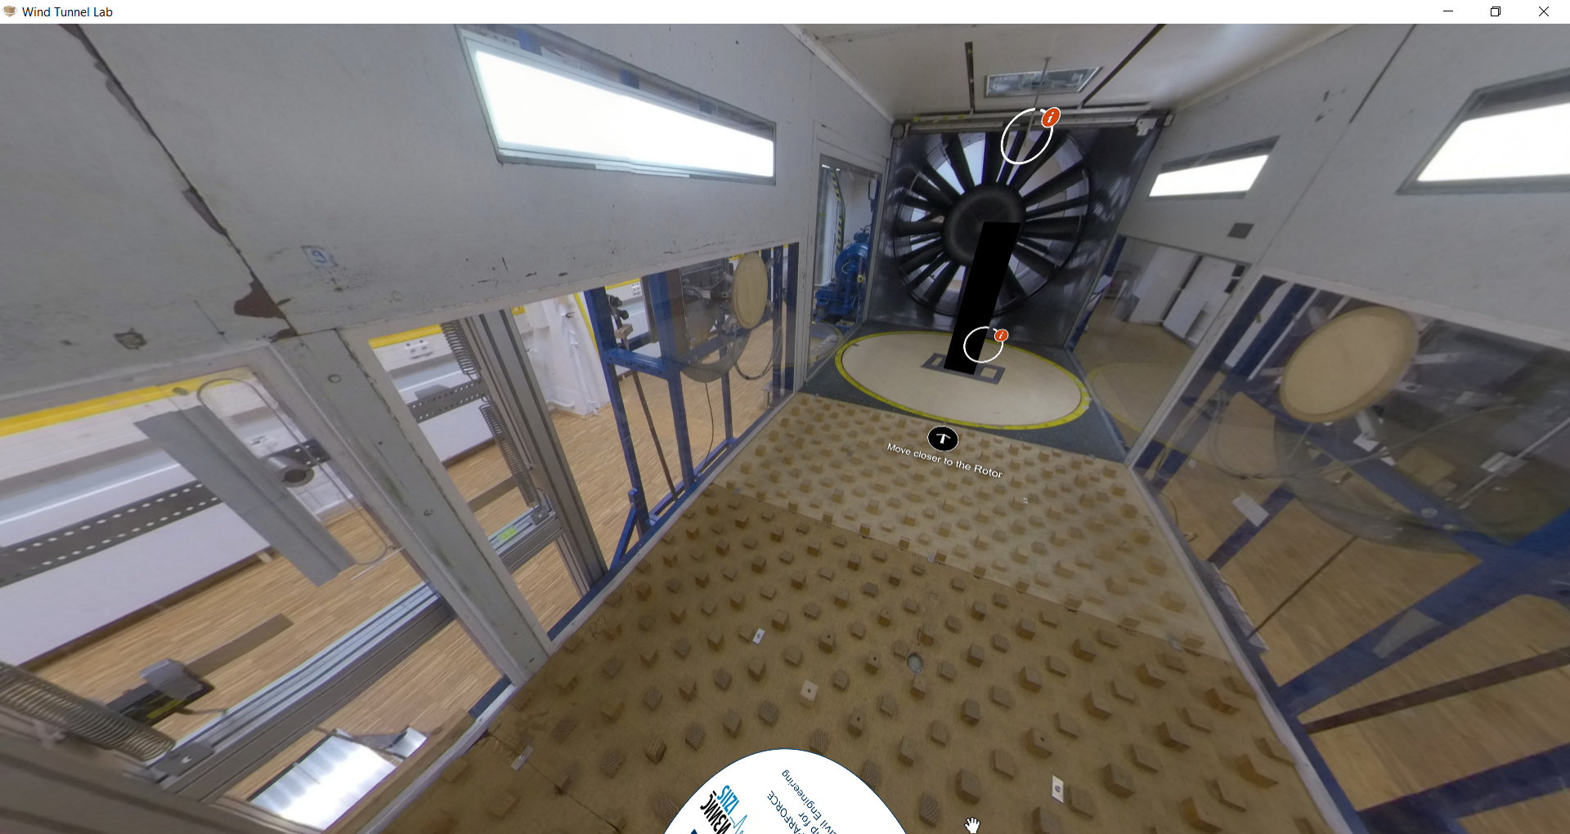

|  |  |  |
| --- | --- | --- |
| Nr | Hotspot (see red arrow) | Script |
| 1 | Hotspot: General description of grouped cylinders experiment | Request to BUW: Can we set the view on the left to be the starting point?  Slide pictures/Album (with text):  Slide-1 Figure:    Slide-1 Text:  Welcome to the wind tunnel experiment of grouped cylinders. The experiment aims to investigate the aeroelastic interactions and effects in several grouped configuration of cylinders. The case of grouped cylinders is based on the transportation of the wind turbine tower before they are installed in the offshore. For the scope of this virtual tour of the wind tunnel, the grouped cylinder experiment will be limited to the 2-in-line configuration, where two cylinders are placed next to each other in close distance. Different wind directions are performed to address the effect of critical wind direction. (Source Figure: Energy Tomorrow Blog. 2015. Photo in Article “Making Offshore Operations Even Safer”. Breakingenergy.com. Accessed on 25 September 2022.)  Slide-2 Figure:    Slide-2 Text:  Atmospheric Boundary Layer profile of the wind flow is experimentally simulated using the castellated barriers, turbulence generators (Counihan vortex generators) and the floor/ground roughness (see the other side of the room). The ABL is simulated under the condition of neutral thermal stratification. The wind profile V(z) profile is referenced to the wind velocity measured by the velocity pressure of the Prandtl Tube. The turbulence intensity profile is determined by fitting the equation to the measured value. The wind speed and turbulence intensity profile can be seen in the figure in this slide.  Slide-3 Figure:    Slide-3 Text:  In general, the grouped cylinders experiment is performed such: 1. Designing the experimental setup and parameters, such as model, structural properties (e.g., mode shape, modal mass, equivalent mass). 2. Manufacturing of the model, installation of the test setup and calibration of the sensors. 3. Validation of structural properties by snap-back or free-decay test. 4. Dynamic test with the given wind flow based on the chosen wind speed variation to be investigated. The test is performed by means of response measurement. 5. Evaluation of the measured response of test structure, for example, the oscillation at the top, lift coefficient, and Strouhal number. In this virtual tour, experiments are provided to estimate the critical wind direction between two in-line grouped cylinders. |
| 2 | Delete the two hotspots | Delete the two hotspots, because it will be described in the other scene “WTInside_Cantilever3” |
| 3 | Hotspot: Ground roughness | Slided Figure+text (Album):  Slide-1 Figure:    Slide-1 Text:  Why do we need ground roughness?  The ground roughness is used to act as an artificial roughness of the earth. Different terrain roughness on the earth’s surface give effect on the shape of atmospheric boundary layer (ABL). Different shape and profile of ABL gives the different wind load on the structure, as the wind speed along elevation may differs. Rougher terrain roughness gives higher turbulence near the ground in the incoming wind than the flatter roughness. (Source Figure: TU Braunschweig)  Slide-2 Figure:    Slide-2 Text  Further information on the effect of terrain roughness can be informatively described (but not limited to), by the Eurocode standard on wind action (EN-1991-1-4). Please note that the figure shown is used for informative purpose of this virtual tour. The analysis of ABL referring to Eurocode has to consider the national annex. (Source Figure: EN-1991-1-4:2005 and DIN EN-1991-1-4/NA:2010)  Slide-3 Figure:    Slide-3 Text:  The actual profile that is experimentally generated by the wind tunnel depends not only on the ground roughness, but also on the former components of the Counihan method, i.e., castellated barrier and vortex/turbulence generator. Therefore, it is important to know the wind profile that occurs in the wind tunnel. Usually, in the beginning of wind tunnel experiment campaign, validation of wind profile is performed by measuring the wind speed along the height of the wind tunnel. (Source Figure: Kipsch, 2010)  Slide-4 Figure:    Slide-4 Text:  In the WISt Wind Tunnel of Ruhr-Universität Bochum, one of the configurations of Counihan method can produce such wind profile, as seen in the figure. The measured wind speed can also be analyzed by its spectra where Von Karman spectrum can be observed. This is an important parameter to characterize the incoming longitudinal wind speed and to estimate the length scale of the incoming vortices. For example, of the spectrum shown in figure, it can give an information about most-dominant vortices’ frequency range referred by the peak of Von Karman spectrum. (Source Figure: Hemida et al., 2020)  Slide-5 Text:  Reference:  [1] TU Braunschweig. *Windingenieurwesen und Bauwerksdynamik*, accessed on 2 October 2022. <https://www.stahlbau.tu-braunschweig.de/index.php/de/menu-forschung-de/menu-forschungsgebiete-de/menu-windingenieurwesen-de>  [2] Eurocode 1 EN 1991-1-4:2005: “Actions on structures - Part 1-4: General actions - Wind actions". English Version. 2010.  [3] DIN EN 1991-1-4/NA:2010-12: „Nationaler Anhang – National festgelegte Parameter – Eurocode 1:Einwirkungen auf Tragwerke – Teil 1-4: Allgemeine Einwirkungen – Windlasten“, 2010.  [4] F. Kipsch. 2010. Geschwindigkeits-und Druckmessmethoden für Modellversuche der Gebäudeaerodynamik im Grenzschichtwindkanal. Ruhr-Universität Bochum.  [5] H. Hemida, A. S. Glumac, G. Vita, K. K. Vranesevic, R. Höffer. 2020. On the flow over high-rise building for wind energy harvesting: An experimental investigation of wind speed and surface pressure. Journal Applied Science, Vol. 10 Issue 15 5283. |
| 4 | Hotspot: Short introduction about Counihan Hardware | Text only:  “In the inlet side of the wind tunnel chamber, a Counihan Hardware is installed. Counihan Hardware or Counihan method is a common practice and to model the atmospheric boundary layer (ABL) in the wind tunnel. The Counihan method dates back to 1969 when it was firstly introduced. It consists of three main parts: castellated barriers, counihan vortex generator, and the ground roughness. The generated ABL which considers the terrain roughness, depends on the design of the castellated barrier, the height and shape of the counihan vortex generator, and the distribution of ground roughness. Further information on each of the component is provided when you move closer to the inlet.” |